caAdapter 4.3
Quick Start Guide

 |   Center for Biomedical Informatics and Information Technology


This is a U.S. Government work. April 30, 2009

Credits and Resources
caAdapter Development and Management Teams
Development | Quality Assurance | Documentation | Project and Product Management
Eugene Wang² | Jyothsna Chilukuri² | Carolyn Kelley Klinger³ | Sichen Lu¹
Ki Sung Um² |  |  | Anand Basu¹
Ye Wu² |  |  | Christo Andonyadis¹
 |  |  | Sharon Gaheen²
- National Cancer Institute Center for Biomedical Informatics and Information Technology (NCI CBIIT) |  | - Science Application International Corporation (SAIC) | - Lockheed Martin Management System Designers

List
caAdapter Users Discussion Forum | https://list.nih.gov/archives/caadapter_users-l.html

Application Support
Application Support | http://ncicbsupport.nci.nih.gov/sw/  Telephone: 301-451-4384  Toll free: 888-478-4423

Contents
Illustrations iii
About This Guide 1
Purpose 1
Organization of this Guide 1
Text Conventions Used 1
Chapter 1 CSV to HL7 V3 Mapping 3
Introduction 3
Hierarchical Tree Structure 4
Composite 4
Leaf 4
Structural Relationship 5
Parent-Child Relationship 5
Sibling Relationship 5
Cardinality 6
Basic Mapping Structure 8
Mapping Types 8
Source Specification 11
Target Specification 12
Types of Mapped Relationships 14
Transformation Service 18
Mapping Example 18
Source Meta Specification 20
Target Meta Specification 21
Mappings 21
Generating the HL7 V3 Messages 22
Conclusion 23
A Word about HL7 V2.x to HL7 V3 Mapping 23
Chapter 2 Converting HL7 V2 to HL7 V3 Messages 24
Methods for Converting HL7 V2 Messages 24
Understanding Mapping and Transformation 24
Step 1: Generating the H3S File 24
Step 2: Creating the .map file 25
Step 3: Transforming a Message from V2 to V3 25
Using the API for HL7 V2 to HL7 V3 Transformation 25

Illustrations
Figure 1. Hierarchical Tree Structure 4
Figure 2. Example of a Parent Child Relationship 5
Figure 3. Sibling Relationship 6
Figure 4. Mappings for Source to Target Specification 10
Figure 5. Example of the Parent-Child Relationship of Source Data 11
Figure 6. COCT_MT999900 Example Message 12
Figure 7. Parts of a Target Specification Structure 13
Figure 8. User Defined Default Value Behavior 13
Figure 9. Example of a Parent Child Inverted Relationship in Mapping Definition 15
Figure 10. Example Result of a Parent Child Inverted Relationship 15
Figure 11. Implicit Mapping on Sibling Structure 16
Figure 12. Sample Output Data 19
Figure 13. Sample Output CSV File 20
Figure 14. Example of CVS Source Specification 20
Figure 15. Example Mapping 21

About This Guide
This section introduces you to the caAdapter 4.3 Quick Start Guide. Topics in this section include
- Purpose on this page
- Organization of this Guide on this page
- Text Conventions Used on page 1

Purpose
caAdapter is an open source application that supports several types of mapping and transformation. It enables analysts and database engineers, who are knowledgeable about HL7, to create a mapping from Comma Separated Value (CSV) clinical data to an equivalent target HL7 V3 XML format. It provides a front end GUI and a back end engine to support specification of file formats, drag-and-drop mapping between source and target, validation of specifications and data, and transformation of actual CSV data into HL7 V3 XML message instances.
Using similar GUI and mapping features, caAdapter also enables HL7 V2 analysts to convert HL7 V2 messages to HL7 V3 mapping capabilities.
In addition, caAdapter supports object to data model mapping. This component allows you to parse and load data and object models from an XMI file, map the object model to the data model using drag-and-drop capabilities, add SDK-required tags and tag values into the XMI file, and generate a Hibernate mapping file.
This guide provides a brief overview to caAdapter 4.3.

Organization of this Guide
This guide includes the following chapters:
- Chapter 1, CSV to HL7 V3 Mapping, on page 3 explains how to use caAdapter to map and convert a CSV files to the HL7 V3 message format.
- Chapter 2, Converting HL7 V2 to HL7 V3 Messages, on page 23 explains how to use caAdapter to map and convert an HL7 V2 message to the HL7 V3 message format.

Text Conventions Used
This section explains conventions used in this guide. The various typefaces represent interface components, keyboard shortcuts, toolbar buttons, dialog box options, and text that you type.
Convention | Description | Example
Bold | Highlights names of option buttons, check boxes, drop-down menus, menu commands, command buttons, or icons. | Click Search.
URL | Indicates a Web address. | http://domain.com
text in Small Caps | Indicates a keyboard shortcut. | Press Enter.
text in Small Caps + text in Small Caps | Indicates keys that are pressed simultaneously. | Press Shift + Ctrl.
Italics | Highlights references to other documents, sections, figures, and tables. | See Figure 4.5.
Italic boldface monospace type | Represents text that you type. | In the New Subset text box, enter Proprietary Proteins.
Note: | Highlights information of particular importance. | Note: This concept is used throughout this document.
{ } | Surrounds replaceable items. | Replace {last name, first name} with the Principal Investigator’s name.

CSV to HL7 V3 Mapping

Introduction
The caAdapter application contains four modules used in CSV to HL7 V3 mapping. The first two allow the user to define the specification for the source and target formats. The third is a mapping tool to help users map a comma-separated value (CSV) specification to an HL7 V3 message specification. The fourth is a transformation service to convert data from a source CSV data file format to a series of HL7 V3 messages, with the mapping file and a CSV data file as inputs.
The purpose of this chapter is to provide users a knowledge base for using the caAdapter Mapping Tool to map a comma-separated value (CSV) specification to an HL7 V3 message specification. This includes instructions on types of specification maps, kinds of specification mapping relationships and resulting output from specific mapping scenarios. To explain the mapping rules further, we will keep the result of the transformation service, that is, the series of HL7 V3 messages, in mind while discussing or illustrating the applications of various mapping rules.
For consistency, here we list a group of generally used terms that will be referenced in later context.
Term | Explanation
CSV Specification | A comma-separated value (CSV) specification that presents the segment-based structure of a series of CSV data files
Source Specification | In current context, it refers to the CSV Specification
HL7 V3 Message Specification | An XML-based specification that is derived from the HL7 .mif file for the selected message type, with customized clone and attribute layout as well as other pre-defined values on data type fields
HL7 V3 XML Specification | Same as HL7 V3 Message Specification
Target Specification | In current context, it refers to the HL7 V3 Message Specification
Map Specification or Map File | An XML-based specification that records the mapping relationship between a source and target specification
CSV data file | A segment-based CSV data file that may conform to a certain CSV Specification hierarchically
Source data file | In current context, it refers to CSV data file
HL7 V3 Message | The outcome of the transformation service, i.e. the XML messages that comply to HL7 V3 specification
Target Message | In current context, it refers to HL7 V3 Message

Hierarchical Tree Structure
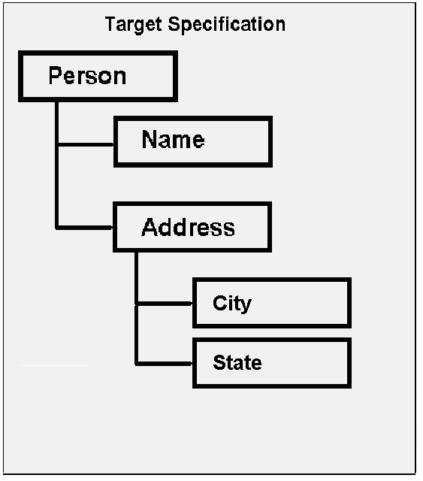
Figure 1. Hierarchical Tree Structure

Composite
A Composite is defined as a hierarchical structure that holds other hierarchical elements. As illustrated in Figure 1. Hierarchical Tree Structure, because the “Person” node holds the “Name” and “Address” nodes, it is a “Composite” structure. Similarly, because the “Address” node also holds the “City” and “State” nodes, it becomes a “Composite” structure as well. In general, a Composite could contain another Composite in its hierarchical structure.

Leaf
A Leaf is defined as a hierarchical structure that does not hold other hierarchical elements. As illustrated in Figure 1. Hierarchical Tree Structure, because the “Name” node does not have any other hierarchical structure beneath it, it is a Leaf node. In general, a leaf node belongs to one and only one Composite structure, while a composite structure could hold more than one Leaf nodes, such as the “Address” Composite.

Structural Relationship

Parent-Child Relationship
In a hierarchical tree structure, we refer to a node as a parent of another node if and only if the defined parent node hierarchically contains the other node. Similarly, we refer to the contained node is the child node of the aforementioned parent node.
For example, in the graphic below, under the source specification, the Organization node is the parent node of the Doctor node beneath it and the Doctor node is a child node of the Organization node.
In contrast, under the target specification, the Doctor node is the parent node of the Organization node beneath it.
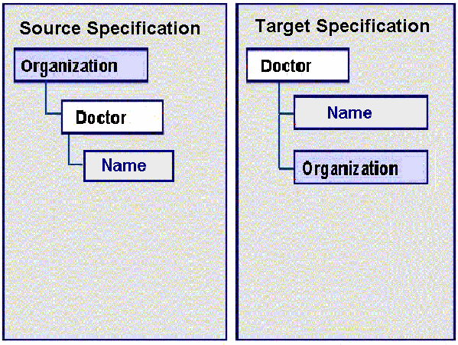
Figure 2. Example of a Parent Child Relationship

Sibling Relationship
Segments, fields, clones, attributes, and data type fields are all types of elements. In source and target specifications, sibling elements are the structures that share an immediate common parent. For example, in the figure below, a Doctor node has ID, Name and Address as its child elements. The ID, Name and Address elements are collectively referred to as siblings under the context of the Doctor parent. In other words, a sibling relationship is always mentioned relative to a given parent element.
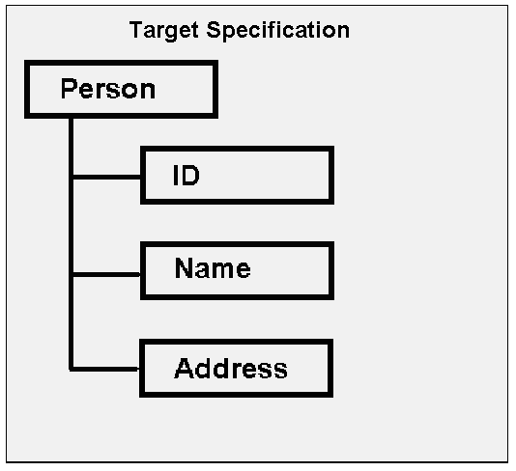
Figure 3. Sibling Relationship

Cardinality
Cardinality, also known as Multiplicity, defines the number of relationship between a parent and its child node, if any. For uniformity, we define the relationship from the parent node’s point of view, but record the cardinality information on the child node side in a properties attribute. Cardinality only denotes the multiplicity relationship between a given node and its immediate parent node.
In the current release, cardinality is implied in the CSV source Specification, while it is explicit in the HL7 V3 message specification. We will elaborate on this further after defining different types of cardinality relationships we may encounter in the caAdapter application.

One-to-One
The one-to-one relationship, denoted as 1..1, implies that the one parent node only contains one and only one such child and conversely, one such child belongs to one and only one given parent node.
In Figure 2, under the target specification, the Name node may have a one-to-one relationship with the parent Doctor node. In other words, if the underlying data contained one Doctor data record that included more than one Name data record, it would cause a validation error between the specification and the data file.

One-to-Many
The one-to-many relationship, as denoted as 1..*, implies that the one parent node could contain one or more of such children and conversely, one or more of such children may belong to one given parent node.
”, under the source specification, the Organization node has a one-to-many relationship with the Doctor node. The definition implies that for one parent Organization node, it will contain minimally one Doctor node and may contain as many Doctor nodes as possible. In real life, it reflects the fact that a small clinic could have at least one doctor, while a large hospital may employ hundreds of doctors in different departments.

Cardinality in Source Specification
In the CSV source specification, cardinality is implied through the parent-child relationship between segments or between a segment and those fields underneath it. There are no numbers to enter or update for cardinality when defining a CSV specification. In fact, between fields and their parent segment, the cardinality is always one-to-one (1..1), that is, one field belongs to one and only one parent segment. From the aspect of parent and child segments, child segments are only needed when there may be a one-to-many relationship between data items. In other words, in the CSV source specification, the child segment has an implied one-to-many cardinality relationship to its parent segment. In the data file, child segments may appear zero, one or many times for each occurrence of a parent segment.
For instance, if the parent segment (PAT) contains data about a patient and the child segment (MED) contains data about medications the patient is taking, a CSV specification may look like this:
PAT
1: PatientId
2: LastName
3: FirstName
4: MiddleName
5: VisitDate
MED
1: AgentName
2: DoseAmount
3: DoseUOM
4: DoseFrequency
5: StartDate

And the data file may look like this:

PAT, 12345, Smith, John, Joseph, 20060123
MED, Ibuprofen, 200, mg, BID, 20060101
PAT, 23456, Green, Peter, David, 20060123
PAT, 34567, Parker, James, Robert, 20060123
MED, Ibuprofen, 200, mg, BID, 20060101
MED, Claritin, 100, mg, BID, 20051001
MED, Prevacid, 500, mg, BID, 20051201

This shows that Smith is taking one medication, Green is currently not taking any medications, and Parker is taking three.

Cardinality in Target Specification
Cardinality in an HL7 V3 message specification is inherited from the HL7 .mif file for the selected HL7 V3 message. Users of the caAdapter application cannot change this cardinality; they can only include or exclude optional portions of the message structure. For elements that are included in the target specification, the cardinality may be one-to-one or one-to-many.

Basic Mapping Structure

Mapping Types
Using the caAdapter Mapping Tool’s CSV to HL7 V3 Map Specification, a user creates links between source fields and target data type fields and between source segments and target attributes or clones. Links between source fields and target data type fields represent data relationships. Links between segments and clones or attributes explicitly relate conceptual groups of data to each other for the purpose of applying cardinality rules.
From such a perspective, we have
- Data mappings specifying the source of the content and the element in the target message where it will go, and
- Concept mappings controling the number of occurrences of message elements in the target messages generated
From a structural perspective, the data mapping is also referred to as the “leaf-to-leaf” mapping, that is, a leaf node in the source tree (source field) to a leaf node in the target tree (data type field).
The concept mapping, in contrast, is also referred to as the “composite-to-composite” mapping, that is, from a source segment to a target clone or attribute. The application does not allow the user, however, to create cross mappings between “composite” and “leaf” elements, that is, map a source field to a target clone or attribute, or map a source segment to a target data type field.
When the caAdapter application generates HL7 V3 messages, four factors will work together to govern the number of instances of message content to be rendered in the results. They are listed in order of consideration as follows:
- The cardinality attribute of the given clone, attribute, or data type field;
- Any explicit conceptual mapping to the given clone or attribute from the source segment;
- If no explicit conceptual mapping is available, any implicit conceptual mapping to be derived by the given clone or attribute from the source segment, if an explicit mapping does not exist;
- The data mapping to the given data type field from the source field;
The current caAdapter application will derive an implicit conceptual mapping from a source field’s or segment’s parent segment to a clone, attribute, or data type field’s parent clone or attribute, if there exists explicit data mappings between the aforementioned source segment or field and target clone, attribute, or data type field, and no explicit conceptual mapping activity is yet defined to reflect the cardinality relationship between the aforementioned source field’s or segment’s parent segment to the aforementioned clone, attribute, or data type field’s parent clone or attribute. For example, the mapping between a child segment and child clone will imply the existence of an implicit conceptual mapping between their respective parents, if no such mapping is explicitly created. In other words, factor 3 is only effectively derived in the absence of factor 2.
In general, during transformation, the caAdapter application will look at each of data type field defined in the target specification to see if any has been mapped to a field in the source specification. If so, it will examine whether the given data type field’s parent attribute or any of its parent attributes or clones above its parent attribute has any explicit conceptual mapping to the source field’s parent segment in the source specification. If so, this conceptual mapping will be utilized as factor 2; otherwise, an implicit mapping relationship is derived between the given data type field’s parent attribute and the given source field’s parent segment in the source specification. Similar implicit mapping relationships will be derived up to the source root segment and the target root clone, or until the first explicit conceptual mapping between a source segment and a target clone or attribute along the path back to the source root segment and the target root clone.
After either implicit or explicit conceptual mapping is decided, the cardinality information of the given data type field is analyzed to help determine the number of occurrences of message elements in messages generated. If the value is 1..1, according to its definition, one and only one message element will be generated and no further computation is needed. If the value is 1..*, however, the cardinality from the implicit or explicit conceptual mapping will be referred to. If the cardinality value from the conceptual mapping is 1..1, it is obvious one and only one message element will be generated and will report warnings if more than one data record exist in the source data file. If the cardinality value from the conceptual mapping is 1..*, the transformation service will create one HL7 V3 message for each occurrence of the data in the source data file.
Since the one-to-one cardinality relationship (1..1) creates one of the strongest bonds between the parent and child nodes, and given the priority in applying mapping rules (see the rule 1), a beginner of this tool may expect several validation error messages regarding mismatched “Multiplicity” or “Cardinality” issues. This is because he or she may have mapped, for instance, a source segment that has one-to-many cardinality, to a target clone or attribute that has only one-to-one cardinality, and the underlying source data of the source specification include more than one data instance of the given source segment.
Therefore, when creating a map file, it is important to first understand the inner structure of the HL7 V3 specification, especially the cardinality definition between parent and child clones and attributes. After that, it is best to start with the concept level relationship before mapping data relationships.
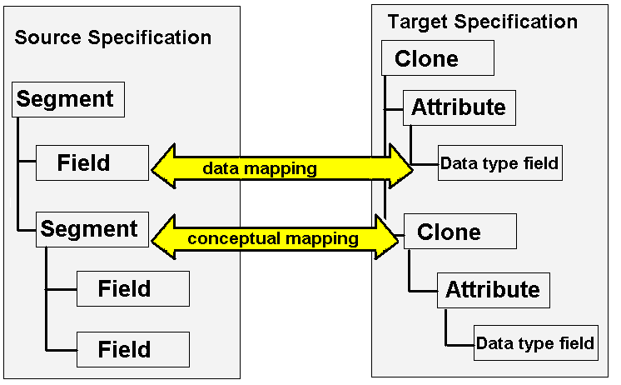
Figure 4. Mappings for Source to Target Specification

Source Specification
This chapter assumes the source data format is a comma-separated values (CSV) file. A comprehensive explanation of the CSV file format could be found in the caAdapter 4.3 User's Guide.
Briefly speaking, the CSV file format is a tabular data format that has fields separated by the comma character.
Example of a CSV file:
John, Doe, 5600 Fishers Lane, Rockville, MD, 20857
Jack, McGinnis, 456 Washington Blvd Suite 1000, Washington, DC, 20002

Each line is a segment containing a logical grouping of fields. Each segment may have one or more dependent child segments to handle one-to-many relationships between logical groups of data. In order to identify the segments for each logical record, segment identifiers are always the first element on each line.
Example of a CSV file:
PERS, John, Doe, 5600 Fishers Lane, Rockville, MD, 20857
PERSID, 2.16.840.1.113883.19.1, 12345
PERSID, 2.16.840.1.113883.19.1, 67890
PERS, Jack, McGinnis, 456 Washington Blvd Suite 1000, Washington, DC, 20002
PERSID, 2.16.840.1.113883.19.1, 24680
In the above example, PERS is the segment identifier showing the root of each logical record. The PERSID segment identifiers show how one logical record can have many child records. The mapping tool will interpret this CSV file as two logical records of PERS each with one to many PERSID segments.
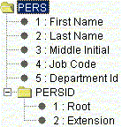
Figure 5. Example of the Parent-Child Relationship of Source Data
CSV source specification structures include a root segment with one or more child segments. A root segment and its child segments represent a single logical record. Each segment has one or more fields that represent elements of data. Segments may also contain one or more child segments that may also include child segments of their own. Mappings link both fields and segments to the XML elements in the target specification structure.
The CSV Specification tab allows users to reorder data fields, change structural relationships, and rename segments. Extra care should be taken when reordering segment structure and renaming segment names. The user should ensure that the source specification segment structure and names match the data file segment structure and names. The Validation action on source specification against CSV data function is very useful for uncovering errors of this type.

Target Specification
This chapter assumes the target data format is an HL7 V3 XML message. An HL7 V3 specification is defined by the content of the HL7 .mif file for the target HL7 message type chosen by the user. A comprehensive explanation of the HL7 V3 specification and HL7 V3 Message can be found in the caAdapter 4.3 User's Guide.
This quick start guide uses a hypothetical example HL7 V3 message for illustration. The example message has a single Act, Participation, Role and Entity.
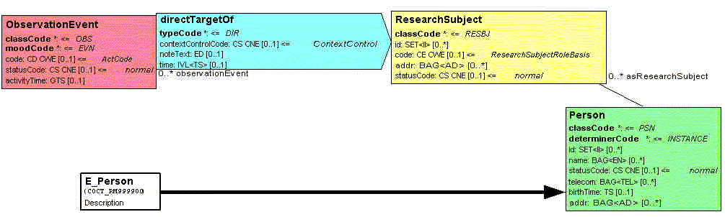
Figure 6. COCT_MT999900 Example Message
Target specification structures include the same elements as the message type. These elements include clones, attributes, and data type fields. Clones are classes derived from HL7 Reference Information Model (RIM) base classes. Each clone can have many child clones and many child attributes. An attributes is assigned a data type based on an independent specification of HL7 V3 data types.
Clones represent concept level hierarchy. Each clone may be associated to one or more child clones that may also be associated to child clones of their own. Some clones are associated to Common Message Element Types (CMETs). These CMETs are a set of one or more clones that represent reusable concepts and may appear in multiple places in a message. In the Mapping Tool users can create mapping links from source segments and fields to target clones, attributes, and data types.
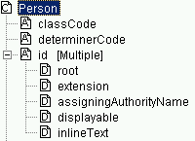
“id” is an attribute
“inlineText” is a data type
“Person” is a clone
Figure 7. Parts of a Target Specification Structure

Defining Default Data
User-defined default values are constants assigned to data type fields. They are defined in the target specification, so they are pre-defined when it comes to the mapping. Please distinguish the “user-defined default value” from the “HL7 default value”, the latter of which is from the HL7 V3 message type defintion and is pre-defined and unchangeable. These user-defined default values allow users to assign values for attributes that may not be available from the source data. For example, if the ‘root’ for all user ids is common across the organization, this value can be entered in the target specification.
User-defined default values are assigned by using the HL7 V3 Specification tab. HL7 structural attributes and other elements that have their values fixed by the HL7 V3 standard cannot have default values defined.
User-defined default values are overridden by values from a mapped data source. While required attributes are often populated with default values specified in the HMD, optional ones are usually only populated when a map is present for that data type field or when a user-defined default value is specified. The table below shows the expected behavior for attributes that are mapped to a non-null CSV Value, mapped but to a CSV value that turns out the be null and unmapped data type fields.
 | Mapped | Mapped Null | UnMapped
Optional | CSV Value | CSV Value | Not Populated
Required | CSV Value | Default Value | Default Value
Mandatory | CSV Value | Default Value | Default Value
Figure 8. User Defined Default Value Behavior
“Mandatory” means that the value may not be NULL, unless its container (clone, attribute, etc.) is NULL. “Required” means values must be supported and may be NULL.

Units of Measure
Some HL7 V3 attributes contain units of measure properties. These units of measure must match those specified in the Unified Code for Units of Measure (UCUM). The Unified Code for Units of Measure is a code system intended to include all units of measure being contemporarily used in international science, engineering, and business. For a complete list, check the following resource:
- The Unified Code for Units of Measure
http://aurora.regenstrief.org/UCUM/ucum.html

Types of Mapped Relationships

Simple Mapping Relationship
Each link is a mapped relationship between source and target hierarchical trees. The combined rules for these mapped relationships define what the generated HL7 V3 message XML will look like.
Most mappings link data fields from a single segment to data type fields of an attribute. This document refers to these relationships as simple relationships because source cardinality and target cardinality have a one to one relationship.
In a simple relationship, one field in the source data file represents one data type field of an attribute on the target XML message.

Parent-Child Inverted Relationship
In a hierarchical tree structure, we define a node as a parent of another node if and only if the defined parent node hierarchically contains the other node. Similarly, we define the contained node is the child node of the aforementioned parent node. For example, in the Figure below, the “Organization” node of the source tree is the parent node of any “Doctor” node beneath it and any “Doctor” node is a child node of the “Organization” node.
Similarly, both source and target specification structures have a parent concept with its child concepts.
In some cases, a child in the source system will be mapped to a parent in the target system. And at the same time, the parent of aforementioned child in the source system will be mapped to a child of aforementioned parent in the target system.
For example, the source specification structure has an organization (parent) with one or more doctors (children). The target specification structure has doctors (parent) who are each associated with an organization (children). In this case each doctor has the same organization. This document refers to this type of relationship as parent-child inverted relationship.
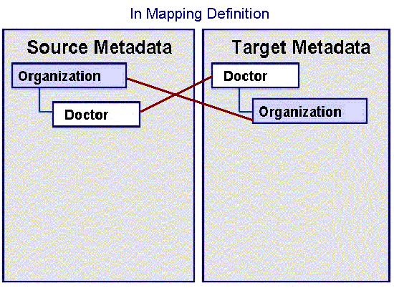
Figure 9. Example of a Parent Child Inverted Relationship in Mapping Definition
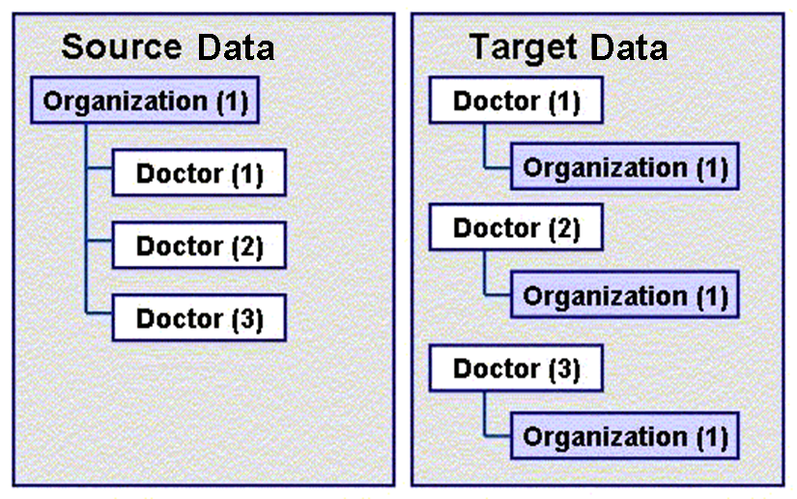
Figure 10. Example Result of a Parent Child Inverted Relationship
In a parent-child inverted mapping, the rules state that:
One parent source datum should be populated for each of the children.
For example, a single organization that has three doctors in the source data will appear as three doctors each with the same organization in the target data. The parent element of source data, in this case the organization, is populated for each of the data type attributes in target.

Siblings
In Sibling, we defined the sibling relationship. With siblings, the mapping rule states that unless an explicit mapping is present for the common parent segment, one element of data in the source data file represents one data type attribute on the target file.
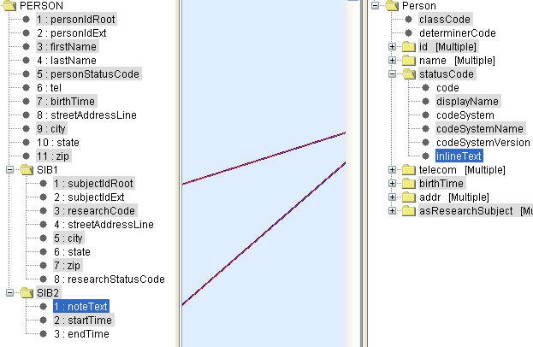
Figure 11. Implicit Mapping on Sibling Structure
For example, in the figure above, PERSON.SIB1.subjectIdRoot from source is mapped to Person.statusCode.codeSystemName in the target and PERSON.SIB2.startTime is mapped to Person.statusCode.inlineText.
According to the sibling rule, Person.statusCode.codeSystemName and Person.statusCode.inlineText from the target are siblings under the Person.statusCode context.
As an extension to the Sibling definition, we also consider that both PERSON.SIB1.subjectIdRoot and PERSON.SIB2.startTime from the source share the same mutual root at PERSON.
To apply the mapping rule stated above, unless there exists an explicit conceptual mapping between PERSON from the source and Person.statusCode at target, 3 records will be generated, given 1 represents SIB1 data and the rest 2 represent information from each of SIB2 data, if the underlying CSV data has the following value set.
Field Names | … … | … … | … …
PERSON | … … | … … | … …
Field Names | subjectIdRoot | … … | … …
SIB1 | 20030102 | … … | … …
Field Names | … … | startTime | … …
SIB2 | … … | B | … …
SIB2 | … … | J | … …
The generated result contains with 3 records. Note that the first record does not have value for “inlineText”, while the second and third records do not have value for “codeSystemName”.
Field Names | … … | codeSystemName | … … | inlineText | … …
Record 1 | … … | 20030102 | … … |  | … …
Record 2 | … … |  | … … | B | … …
Record 3 | … … |  | … … | J | … …

On the other hand, if there does exist an explicit mapping between PERSON from source and the Person.statusCode from the target, the cardinality definition of the common parent, i.e., the PERSON element from the source will have weight on the number of records being generated. For instance, if the cardinality of the PERSON element from the source is 1..1, one and only one record will be rendered in the result, no matter how many source data record of each SIB1 or SIB2 exist, although a validation error will be reported on the mismatched cardinality because more than one data from SIB2 exist.
If the cardinality of the PERSON element from the source is 1..*, however, the actual number of data on SIB1 and SIB2 in the real data file will rule.

Conceptual Relationship
All mappings have an explicit or implicit conceptual relationship between source and target elements. An implicit relationship is defined by the nature of the link. For example, a child segment mapped to child clone implies the existence of an implicit relationship between their common parents. The mapping tool also supports explicit mapping, where the user creates a link between a source segment and a target clone, or between a source segment and a target attribute. Under the explicit conceptual mapping, unless the target has one-to-one (1..1) cardinality relationship with its parent, the cardinality from the source will help govern the number of records of the targeted node being generated, given its underlying children nodes’ mapping structure.

Transformation Service
The caAdapter Mapping Tool uses the transformation service to determine target message structure based on mapping rules. These rules are based on the types of mapped relationship used in the .map file.
The Transformation Service builds the HL7 V3 XML message. It creates the message by traversing an object graph of HL7 clone objects. It then creates and populates these clone data objects based on the mapping rules.

Mapping Rules
In order for clones to be aggregated, a relationship needs to be established between the target clone and a source segment. The following rules define how these relationships are derived:
- The transformation service checks for conceptual mappings to the target clone in question. These are treated as having an explicit relationship between the target clone and the source segment.
- The transformation service checks for data mappings to the target clone in question. All source segments that are mapped to attributes of this target clone are treated as having an implicit relationship between the target clone and those source segment(s). Then the common parent of these segments is derived.
- The number of target clones created equals the number of corresponding implicit or explicit source segments.
- Child target clones will inherit the implicit or explicit source segments relationships from their parent clones. In these cases a single clone is created.

Mapping Functions
Functions are inline processes that are used to provide certain transformations to the data during map processing. For example, the concatenate function can combine two fields in the source data file into a single data type attribute.
Only fields from a single segment can be used as input to a function.
Functions can be chained together to offer a series of actions to one target attribute. In these cases all inputs to the chain of functions have to be from the same source segment.

Mapping Example
This section will provide an example and walk through the steps required to transform a segment-based CSV data file to HL7 V3 mappings. Files for this example are located in the Scenario8 directory in the Mapping Scenarios folder.
This example will
- Generate the segment-based CSV data from the sample output data;
- Generate CSV segment specification, a.k.a. SCS file, from the segment-based CSV data;
- Generate HL7 V3 specification, a.k.a. H3S file after some customizations of clone structure and filling in user default values, if any, from the pre-defined COCT_RM999900 HMD template;
- Create mapping specification, a.k.a. Map file, to design the mapping relationship between the SCS and H3S files, via the caAdapter mapping panel;
- Render the HL7 V3 messages given both the sample segment-based CSV output data and the mapping specification as inputs;
The sample output data is organized by patient record (PERSON). Each patient record (PERSON) participates as a research subject (RESEARCHSUBJECT) as the target (DIRECTTARGET) of an observation (OBSERVATIONEVENT).
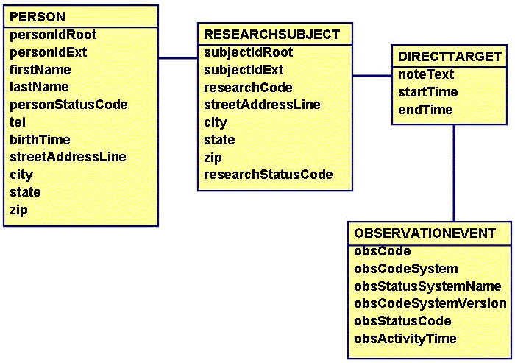
Figure 12. Sample Output Data
Using the sample output data, a CSV data file is generated. Each one-to-many relationship becomes a segment with the PERSON segment being the root.
PERSON, 2.16.840.1.1138..., 12345, John, Smith, 01, 800-555-9999, 20030102, 456 Washington Blvd, Washington, DC, 20002
RESEARCHSUBJECT, 2.16.840.1.113883.19.1, 12345, ABC123, 456 Washington Blvd, Washington, DC, 20002, 01
DIRECTTARGET, This is target 1, 20030102, 20030704
OBSERVATIONEVENT, ABC123, 2.16.840.1.113883.5.4, caDSR, 3.01, 01, 20030607
DIRECTTARGET, This is target 2, 20030704, 20040214
OBSERVATIONEVENT, LMO456, 2.16.840.1.113883.5.4, caDSR, 3.01, 01, 20030823
DIRECTTARGET, This is target 3, 20050315, 20050926
OBSERVATIONEVENT, XYZ789, 2.16.840.1.113883.5.4, caDSR, 3.01, 01, 2005076
Figure 13. Sample Output CSV File

Source Meta Specification
The CSV segment specification, a.k.a. SCS file, is created from the sample output CSV file.
Field names and segment structure are defined by use of the “scs” panel in the caAdapter application. Users can rename names of field and segment elements. Users can also modify parent-child relationship between segment and field or between segments by dragging and dropping source segments or fields onto the targeted segment location. In addition, users may reshuffle the order of field elements under the same segment, to furnish alternative layout of data structure. These structural relationships (i.e. parent-child, siblings, etc.) are essential, because combined with actual CSV data, they will contribute to the way how the transformation service interprets the mapping relationships in generating the target HL7 V3 messages.
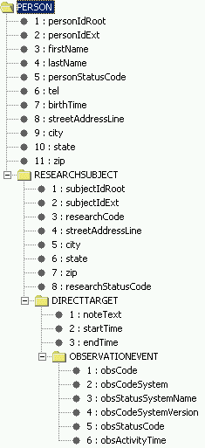
Figure 14. Example of CVS Source Specification
In our example each of the source segments is a child of the segment that came before it.

Target Meta Specification
The example target specification specification (the .H3S file), includes default values defined for some fields or default clone layout per generic message type. For example, observationEvent code has a default codeSystem already applied. The codeSystem is the same for all messages created with this h3s specification file. Multiple instances of clones or data types could have also added to the target specification.

Mappings
Each transformation from the source specification (SCS file) to the target HL7 V3 specification (H3S file) in this example requires an explicit mapping relationship. In the example, an explicit map exists between DIRECTTARGET and the HL7 V3 clone of asResearchSubject.
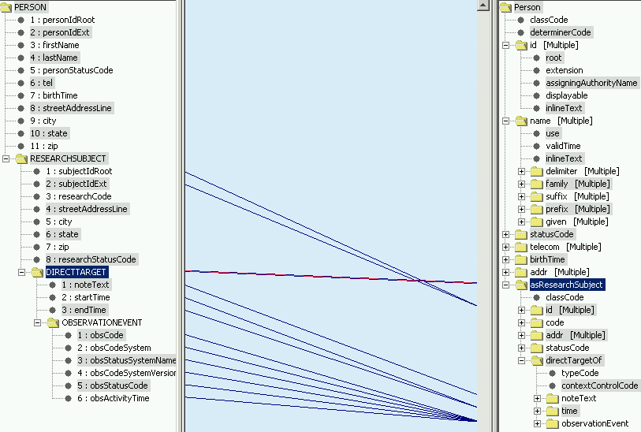
Figure 15. Example Mapping
The rest of the mapping is simple one to one maps, between the source specification and target specification.

Generating the HL7 V3 Messages
After the map file is created, users could utilize the HL7 V3 message generation utility in the caAdpater application to render the HL7 V3 message instances for the mapped HL7 V3 specification. Following is the example HL7 V3 message.

<?xml version="1.0" encoding="UTF-8"?>
<COCT_MT999900.Person classCode="PSN" determinerCode="INSTANCE">
<asResearchSubject classCode="RESBJ">
<id root="2.16.840.1.113883.19.1" extension="12345"/>
<code/>
<statusCode/>
<directTargetOf typeCode="DIR">
<noteText>This is target 1</noteText>
<time>
<low value="20030102"/>
<high value="20030704"/>
</time>
<observationEvent classCode="OBS" moodCode="EVN">
<code code="ABC123" codeSystem="2.16.840.1.113883.5.4" codeSystemName="caDSR" codeSystemVersion="3.01"/>
<statusCode code="01" codeSystem="2.16.840.1.113883.19.1"/>
<activityTime value="20030607"/>
</observationEvent>
</directTargetOf>
</asResearchSubject>
<asResearchSubject classCode="RESBJ">
<id root="2.16.840.1.113883.19.1" extension="12345"/>
<code/>
<statusCode/>
<directTargetOf typeCode="DIR">
<noteText>This is target 2</noteText>
<time>
<low value="20030704"/>
<high value="20040214"/>
</time>
<observationEvent classCode="OBS" moodCode="EVN">
<code code="LMO456" codeSystem="2.16.840.1.113883.5.4" codeSystemName="caDSR" codeSystemVersion="3.01"/>
<statusCode code="01" codeSystem="2.16.840.1.113883.19.1"/>
<activityTime value="20030823"/>
</observationEvent>
</directTargetOf>
</asResearchSubject>
<asResearchSubject classCode="RESBJ">
<id root="2.16.840.1.113883.19.1" extension="12345"/>
<code/>
<statusCode/>
<directTargetOf typeCode="DIR">
<noteText>This is target 3</noteText>
<time>
<low value="20050315"/>
<high value="20050926"/>
</time>
<observationEvent classCode="OBS" moodCode="EVN">
<code code="XYZ789" codeSystem="2.16.840.1.113883.5.4" codeSystemName="caDSR" codeSystemVersion="3.01"/>
<statusCode code="01" codeSystem="2.16.840.1.113883.19.1"/>
<activityTime value="2005083"/>
</observationEvent>
</directTargetOf>
</asResearchSubject>
</COCT_MT999900.Person>

Conclusion
The example shows the steps to generate HL7 V3 messages from a segment-based CSV data file. To build the mapping file, users need to have both the SCS and H3S files available. The SCS and H3S files could be created and modified by utilizing the SCS and H3S modules, respectively, in the caAdapter application. Once the map files have been created, HL7 V3 message instances will be generated via HL7 V3 message module for the mapped HL7 V3 specification.

A Word about HL7 V2.x to HL7 V3 Mapping
caAdapter 4.3 contains a module for generating an SCS from a set of specifications for HL7 v2.x elements (messages, segments, data types and vocabularies) This modules also has the ability to convert an HL7 v2.x message instance into a CSV file that complies with the V2.x-based SCS. Thus the mapping of V2.x elements to HL7 V3 elements is accomplished using the CSV to HL7 V3 Mapping module. All the same business rules apply in this context as for a normal CSV to HL7 V3 mapping that is not based on a V2.x-based SCS. Depending on the complexity of the message, it is quite likely that analysts will need to be very familiar with the conceptual mapping described above to successfully create a v2.x-based CSV to HL7 V3 mapping. In such a case, trial and error is the best teacher. It is recommended that analysts test the transformation frequently as they build the mappings so that they learn how conceptual mapping guides the transformation engine.

Converting HL7 V2 to HL7 V3 Messages
This chapter provides instructions on using caAdapter to map and convert an HL7 V2 message to the HL7 V3 message format.
Topics in this chapter include:
- Methods for Converting HL7 V2 Messages on page 23
- Understanding Mapping and Transformation on page 23

Methods for Converting HL7 V2 Messages
You can convert an HL7 V2 message to an HL7 V3 message using XML-formatted HL7 V2 resources, which are available as a free download at the HL7 home page, http://www.hl7.org. HL7 V2 messages can be directly converted to HL7 V3 messages without any pre-processing. Since this method does not validate HL7 V2 syntax and vocabulary, you would achieve the best results if you use another tool to validate and filter the source HL7 V2 message.
The current V2-related functions in the caAdapter GUI menus and all the explanations in this chapter use the method described above. If you need to use the legacy method, refer to earlier versions of the caAdapter User’s Guide or contact Application Support.

Understanding Mapping and Transformation
When you convert an HL7 V2 message to HL7 V3 format, an SCS file is not required. You must only select the HL7 V2 version and message type in the mapping panel.
The process of transforming HL7 V2 messages to the HL7 V3 message format has the following three steps.
- Generate an H3S file for the target HL7 V3 message (see Step 1: Generating the H3S File, below)
- Create a .map file between the source HL7 V2 message type and the target H3S file (see Step 2: Creating the .map file on page 24)
- Transform and generate a V3 message from the source HL7 V2 message file using the .map file (see Step 3: Transforming a Message from V2 to V3 on page 24)

Step 1: Generating the H3S File
Generating an H3S file for HL7 V2 to HL7 V3 mapping follows the same process as explained in Transforming an HL7 V3 Message to CSV Format on page 56.
Knowing which V3 message type is appropriate for a given V2 message type is extremely important.
Proceed to Step 2: Creating the .map file, below.

Step 2: Creating the .map file
To create the .map file
- Select New > HL7 V2 To HL7 V3 Mapping and Transformation Service > New HL7 V2 to HL7 V3 Map Specification. The main mapping panel appears.
- Click the Open Source button. The HL7 V2 Schema Selection dialog box appears.
- Select the HL7 V2 message version and schema. Click OK. The HL7 V2 message tree appears on the left side of the window.
For more information on working with mapping files, see the caAdapter 4.3 User's Guide.

Step 3: Transforming a Message from V2 to V3
When you transform a message from HL7 V2 to HL7 V3, your input file type is .hl7. You must save your source HL7 V2 message as an .hl7 file before transforming it.
To transform a message from HL7 V2 to HL7 V3
- Select New > HL7 V2 to HL7 V3 Mapping and Transformation Service > New HL7 V2 to HL7 V3 Message. The New HL7 V2 to HL7 V3 Message dialog box appears.
- In the Data File field, click Browse. The Open dialog box appears. Locate an .hl7 file and then click OK. The New HL7 V2 to HL7 V3 Message dialog box appears.
- In the Map Specification field, click Browse. The Open dialog box appears. Locate a .map file and then click OK. The New HL7 V2 to HL7 V3 Message dialog box appears.
- In the Result File field, click Browse. The Open dialog box appears. Locate a .zip file and then click OK. The New HL7 V2 to HL7 V3 Message dialog box appears.
- Click OK.

Using the API for HL7 V2 to HL7 V3 Transformation
You can use the caAdapter API to transform HL7 V2 messages to HL7 V3 format.
Earlier versions of caAdapter required two steps to transfer HL7 V2 messages to HL7 V3. First the messages had to be converted to CSV using KNU (Kyungpook National University) V2 parser engine. This process includes V2 message syntax and vocabulary validating, and can process segments such as ‘OBX’. In the second step, caAdapter transformed the CSV file to an HL7 V3 message. If you have a legacy application using this earlier process, legacy APIs are included in the caAdapter distribution.

